

RECORD OF TITLE

UNDER LAND TRANSFER ACT 2017   
 CROSS LEASE

Guaranteed Search Copy issued under Section 60 of the Land   
 Transfer Act 2017

Identifier

NA79D/221

Land Registration District North Auckland

Date Issued 23 January 1990

Prior References

NA66B/681

Estate Fee Simple - 1/2 share

Area 970 square metres more or less

Legal Description Lot 126 Deposited Plan 116690

Registered Owners

Kenneth James Medley and Helen Michelle Medley

Estate Fee Simple - 1/6 share

Area 153 square metres more or less

Legal Description Lot 195 Deposited Plan 116690

Registered Owners

Kenneth James Medley and Helen Michelle Medley

Estate Leasehold

Legal Description Flat 1 Deposited Plan 135216

Registered Owners

Kenneth James Medley and Helen Michelle Medley

Instrument L C093527.2

Term 999 years commencing on the 13th

December 1989

Interests

Land Covenant in Transfer B846958.2 (Affects Fee Simple)

Subject to Section 308 (4) Local Government Act 1974 (Affects Fee Simple)

Land Covenant in Lease C093527.2 - 23.1.1990 at 2.00 pm (Affects Fee Simple)

C093527.2 Lease of Flat 1 DP 135216 Term 999 years commencing on the 13th December 1989 Composite CT NA79D/221 issued - 23.1.1990 at 2.00 pm (Affects Fee Simple)

C253132.1 Lease of Flat 2 DP 143218 Term 998 years commencing on the 13.12.1990 Composite CT NA84D/589 issued -

8.4.1991 at 11.18 am (Affects Fee Simple)

Land Covenant in Lease C253132.1 - 8.4.1991 at 11.18 am (Affects Fee Simple)

5797826.3 Mortgage to The National Bank of New Zealand Limited - 13.11.2003 at 9:00 am 11226190.1 Variation of Mortgage 5797826.3 - 14.9.2018 at 4:34 pm

*Transaction ID* *64514391* *Guaranteed Search Copy Dated 30/04/21 11:32 am, Page 1 of 3*

*Client Reference Quickmap* *Register Only*

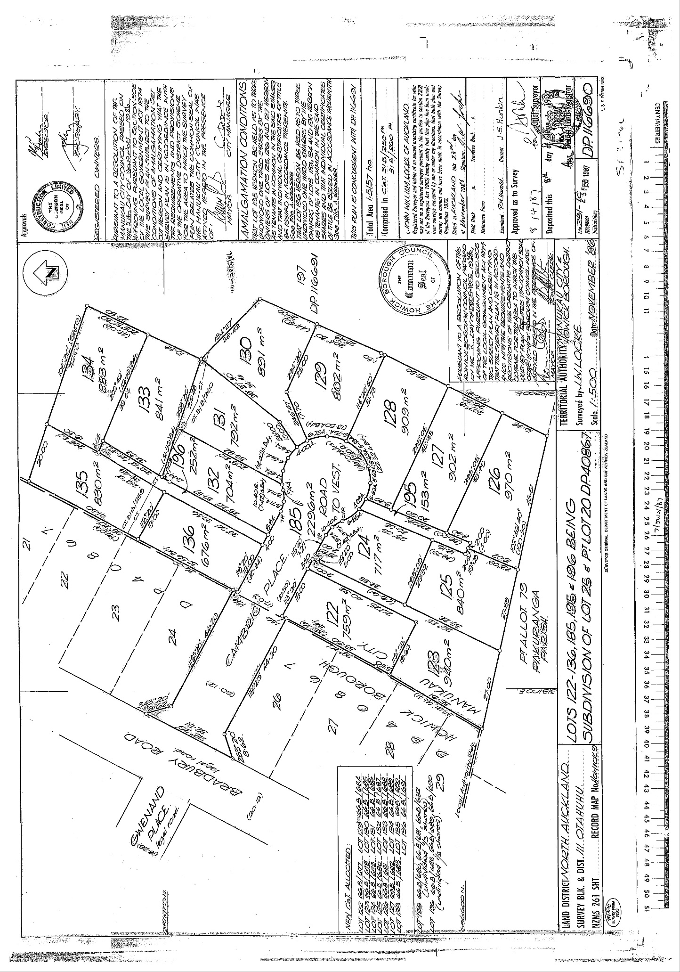

Identifier

NA79D/221

*Transaction ID* *64514391* *Guaranteed Search Copy Dated 30/04/21 11:32 am, Page 2 of 3*

*Client Reference Quickmap* *Register Only*

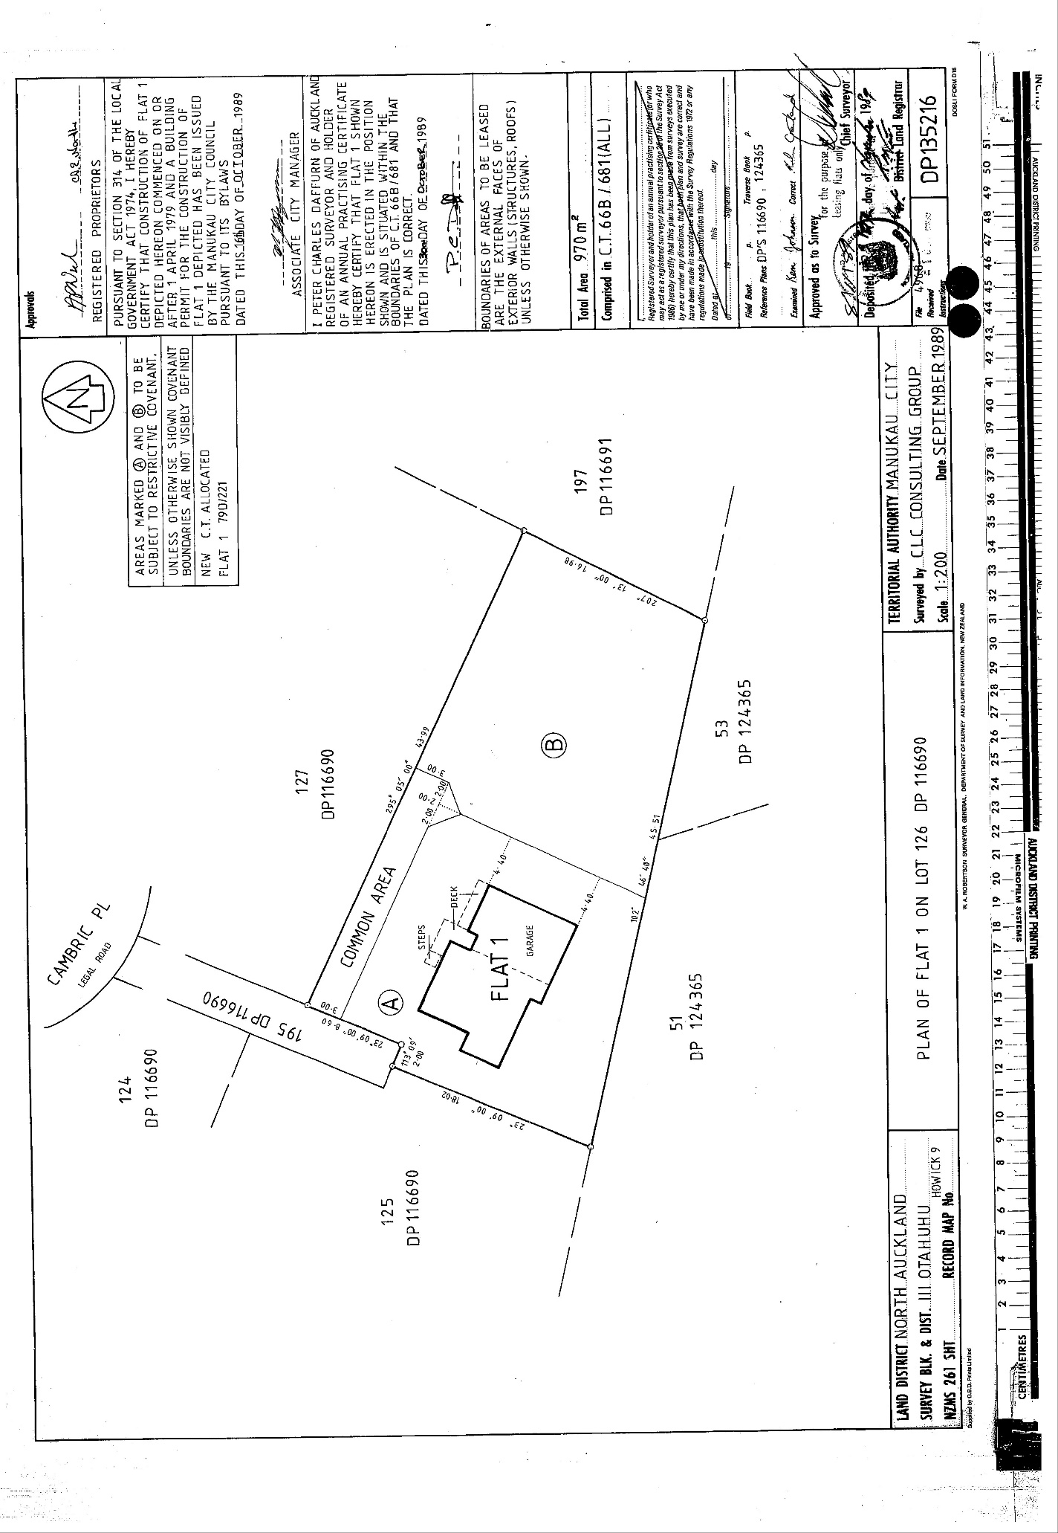

Identifier

NA79D/2

*Transaction ID* *64514391* *Guaranteed Search Copy Dated 30/04/21 11:32 am, Page 3 of 3*

*Client Reference Quickmap* *Register Only*